Assignment 3

Building a Multi-layer network using back propagation algorithm in R and Weka

# R:

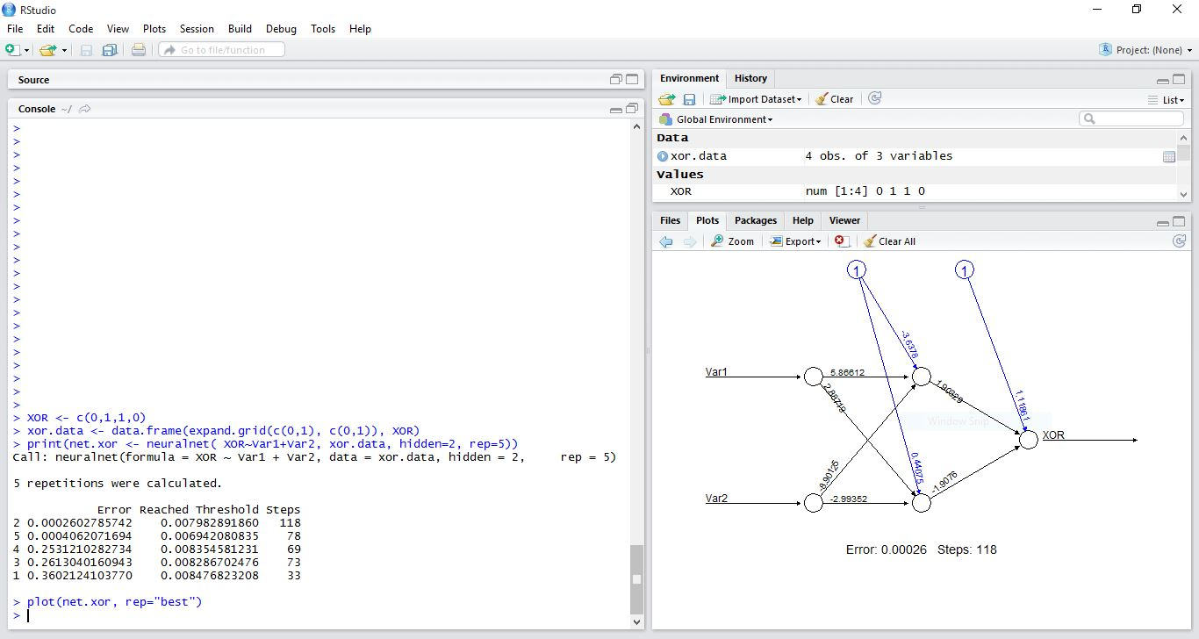

The number of nodes in the hidden layer are 2.

The neural network was built using the **neuralnet** package available in R. The code ran for 5 iterations and the above screenshot shows the number of epochs in each iteration. From the output, it is apparent that as the number of steps increase, the error rate goes down.

The figure on the right side shows the weights assigned to each node in the best iteration with the least error.

# Weka:

The number of nodes in the hidden layer are same as above i.e 2.

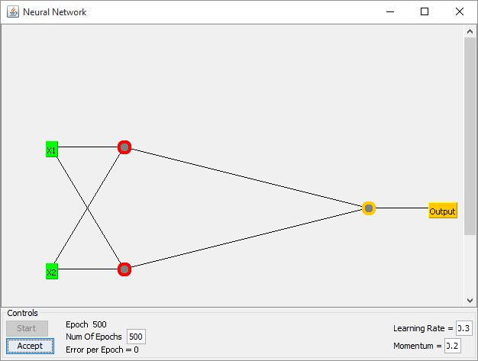

The result obtained is as follows:

=== Run information ===

Scheme:weka.classifiers.functions.MultilayerPerceptron -L 0.3 -M 0.2 -N 500 -V 0 -S 0 -E 20 -H 2 -G -R

Relation: PerceptronXOR

Instances: 8

Attributes: 3

X1

X2

Output

Test mode:evaluate on training data

=== Classifier model (full training set) ===

Linear Node 0

Inputs Weights

Threshold -1.1754251055186928

Node 1 3.1090505088249922

Node 2 -3.1956771495670497

Sigmoid Node 1

Inputs Weights

Threshold 0.9056634139194272

Attrib X1 1.8649351996481398

Attrib X2 1.8572252703712682

Sigmoid Node 2

Inputs Weights

Threshold -4.413415708218539

Attrib X1 3.4197614096348117

Attrib X2 3.2900624457310395

Class

Input

Node 0

Time taken to build model: 88.22 seconds

=== Evaluation on training set ===

=== Summary ===

Correlation coefficient 1

Mean absolute error 0

Root mean squared error 0

Relative absolute error 0 %

Root relative squared error 0 %

Total Number of Instances 8

# Group members:

* Rohit Kumar Sharma
* Anudeep Reddy D
* Kshitij Sharma
* Abhishek Kaushik